CLASS 4 DATE 02-06-2024
CLUSTERING:
Cluster : Group of Laptops/Instances combines to say as Cluster, which has Gateway Node, Data Node, Master node etc.
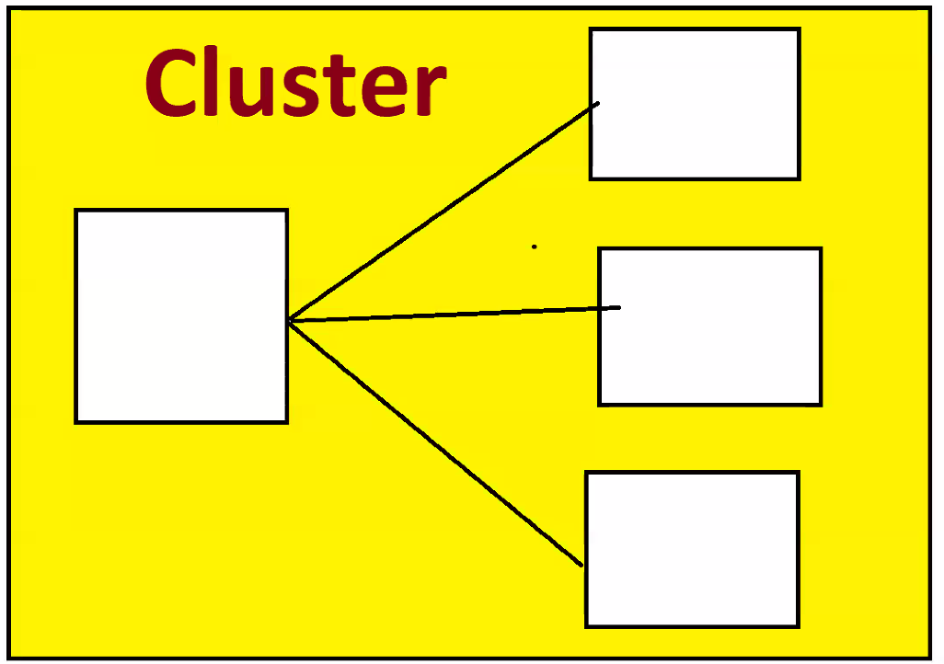
Take 5 laptops/Machines of each 1TB Capacity, install Hadoop in each and interconnect all machine, it becomes 5TB of HDFS(Hadoop Distributed File System). 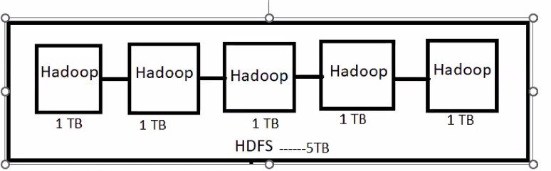
To communicate with HDFS, we need a Gateway Node/Laptop/Machine and specialized softwares like Putty, Mobaxterm. With help of putty or Mobaxterm connect to Gateway Node via IPAddress / HOSTNAME.
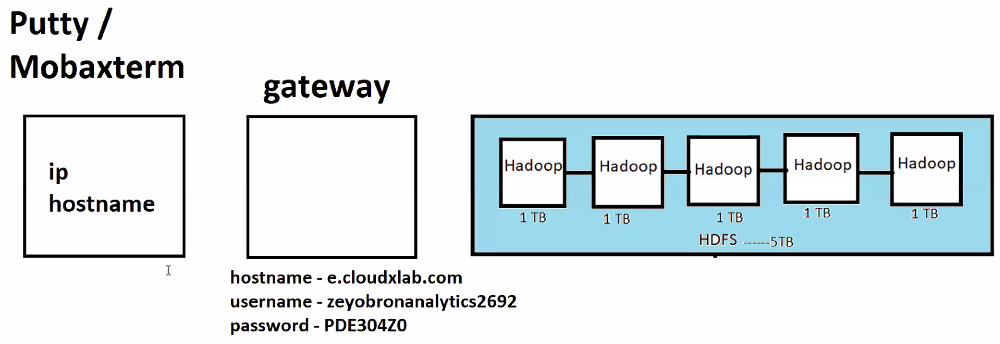

Gateway laptops are powered with Linux Operating System. If we want to talk to Gateway Node, we need to Execute/fire Linux commands.
In order to communicate with HDFS, we directly cannot connect to HDFS, instead we connect to Gateway node and communicate in Hadoop language. Gateway node will help taking our instructions to HDFS.
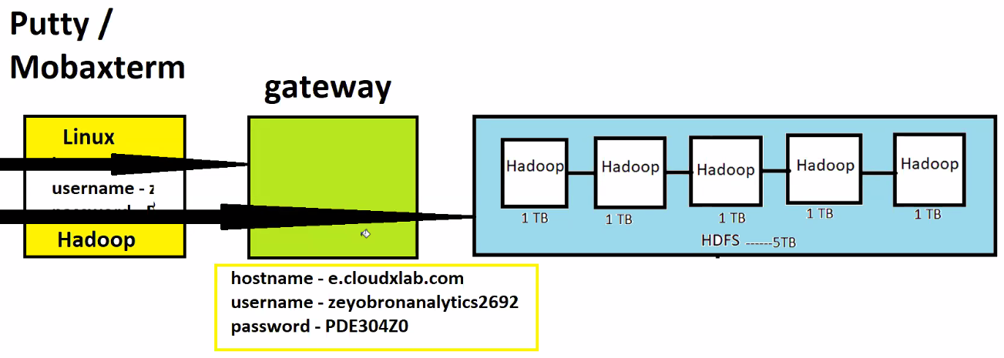
Linux commands ls Command Gateway Node will respond.
Hadoop Commands Hadoop fs -ls HDFS will respond.
HDFS has one Name Node, Secondary Name Node and rest all are Data nodes.
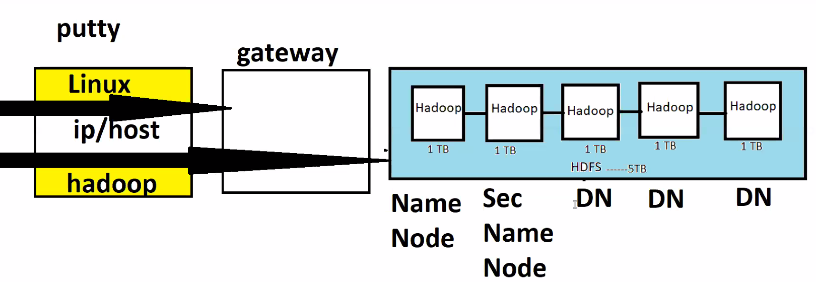

Corporate Story:
There’s product company (say Facebook) agreed to give work to service company (say tcs).

The work is about is get started next week and fb getting prepared to give work to tcs. Tcs started allocating/recruited Delivery manager, and started building a team.
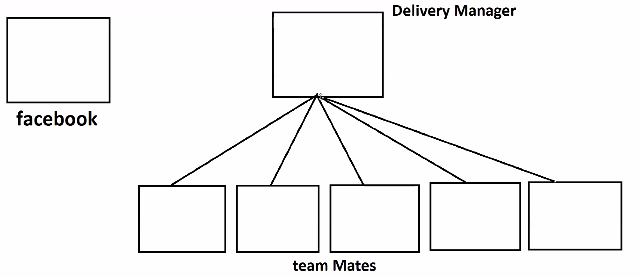
Delivery manager thought of interacting with teammates, one fine day he visited office to meet teammates and asked teammates to meet at conference room. Now Delivery manager started giving some instructions, he gave 4 mandatory instructions to all his teammates:
- Obey me as I’m your manager.
- To understand you are active for every three seconds, raise your hands.
- If you don’t raise for 3sec, I’ll give time till 10 minutes to raise hands, if you don’t raise your hands then I’ll consider you as dead.
- If you got any work from client, please give 2 copies of work to other teammates.
Teammates all went to their desk and started raising their hands.
Now, Fb got some work to do, asked delivery manager about his work.
Delivery manager maintains some excel to keep track of teammates who all are free or occupied. Then delivery manager responded back to FB and said as the work is big, asked it to allocate it to 2 teammates.
Now, teammates who got work, they replicate that work to 2 other teammates.
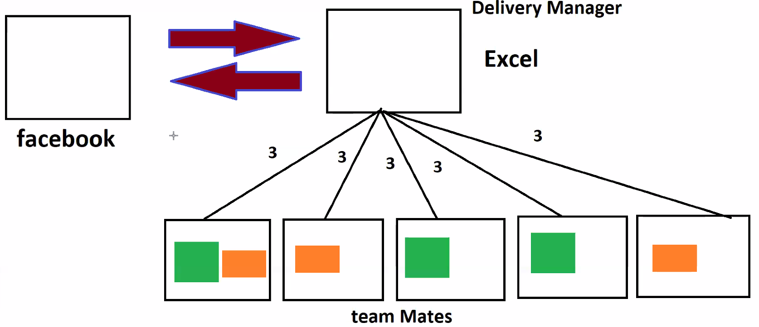
All went very well for 3 days, every teammate is working. Now teammate 1 stopped raising the hand. Manager waited 10mins and teammate 1 didn’t respond for 10 mins and manager considered him as dead.
As the replications got decreased because teammate is dead. Manager asked temmate2 to replicate work to maintain 3 copies. Then manager removes the one how dead and recruits the new one, then he will balance the work by sending the work to new teammate.
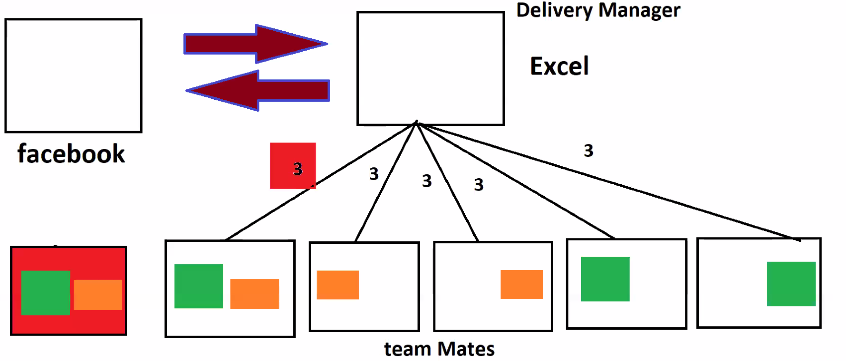
Now, all of a sudden before removing dead teammate, started raising the hand. Then teammate1 stated that he’s not dead, he said, he is sleepy. Now, Issue is we have 4 replicas of work. Now, Manager asked teammate1 to delete all his work and manager balanced the work to maintain 3 replicas.
Now Analogy linking to HDFS:
Facebook is Gateway node, Tcs is Name Node, teammates are data nodes. Edge Node & client all are other names to Gateway node.
Rules of Name Node:
- Obey me
- For every 3 sec, send me Small Java heart Beat code.
- 10 min Stale time.
- If you got any data, maintains 3 replicas
HDFS Architecture:
When Edge Node gets data of 200MB, Name node checks fsimage and says data is huge asks edge node to divide it as max limit is 128MB. Now 200mb of data gets divide into 128mb and 78mb and data will be sent to all data nodes and maintains 3 replicas.
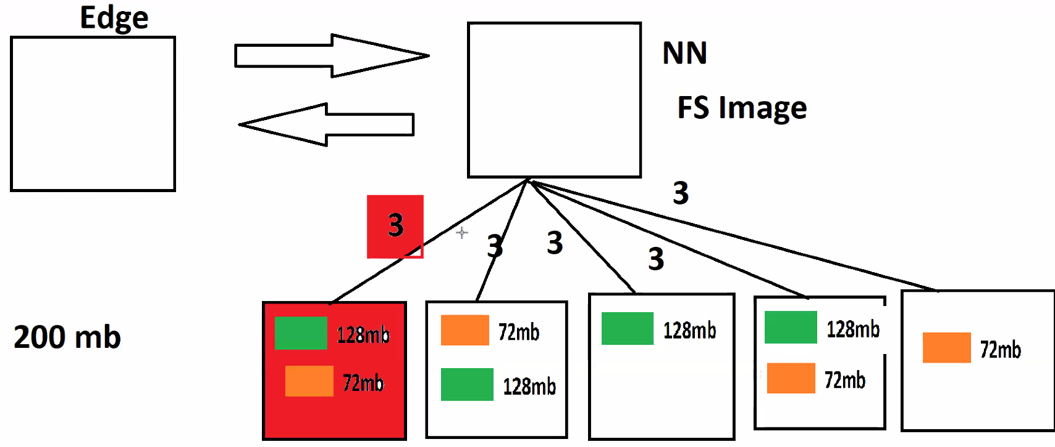
If any of the datanode is dead, namenode brings another new datanode and replicates the data to maintain 3 replicas. If dead datanode starts responding back, name node ask’s that datanode to delete all the data it has and name node manages the work to maintain 3 replicas.

INSTALLATION STEPS:
- Install 7Z
- Install Virtual box. Windows 10 virtual 6/7 or Windows 10 virtual 7
- Extract Cloudera using 7z.
- Open Virtual Box and pull extracted cloudera.
Name:powered version changes to Redhat. If 64 bit no problem. If we get 32 we have to enable VTX.
Base memory 8gb ram go with 4000MB
Processors : 2
Tick Use existing virtual disk file then add extracted cloudera using 7g

Steps to enable VTX:

- Got to settings advanced make it bidirectional.
Installation videos:
🔴 windows 10 Virtual 6 set up steps VIDEO or go with Virtual 7
https://youtu.be/xsTbkZ8r1qo
🔴 Windows 11 Virtual 7 set up steps VIDEO
https://youtu.be/u1x0ZMEeefU
🔴 MAC Installation Steps
https://youtu.be/WESGq7tPRxQ

